**LAB-4**

**TASK.1**

The cardverify class is designed to validate a card number using the **Luhn algorithm**. It takes a card number as input during initialization and provides a method is_valid() to check its validity. The algorithm works by reversing the card number, doubling every second digit, subtracting 9 from values greater than 9, and summing all digits. If the total sum is divisible by 10, the card number is considered valid. The program demonstrates this by creating an instance of the class and calling is_valid() to print the result.

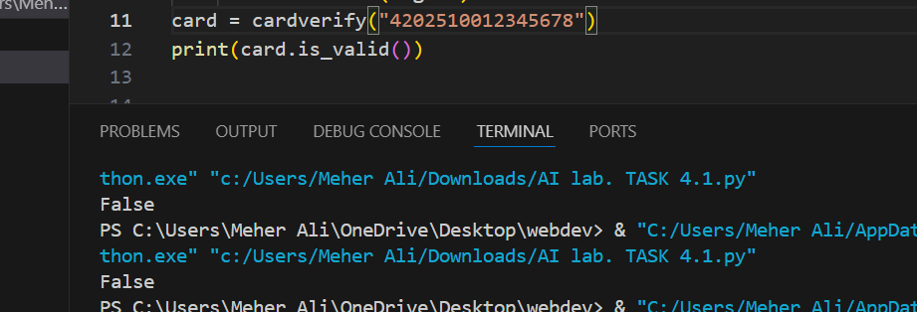

**TASK.2**

The MsgCleaner class is designed to remove special characters from a given string, keeping only alphanumeric characters and spaces. It initializes with a message and provides the clean_msg() method to filter out unwanted characters. The method iterates through the string, appending only letters, numbers, and spaces to a new result string. The program takes user input, creates an instance of MsgCleaner, and prints the cleaned message.

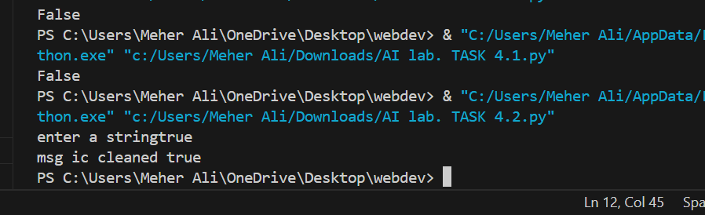

**TASK.3**

The MsgSorter class sorts the words in a given sentence in alphabetical order. It initializes by splitting the input message into a list of words. The alphabetically() method uses a nested loop to compare and swap words, sorting them in ascending order. Finally, the sorted words are joined into a string and returned. The program takes user input, creates an instance of MsgSorter, and prints the sorted message.

